**Tutorial 2 – Dynamic system Analysis**

**Modeling and simulation (no report)**

***Satellite antenna with flexible solar panels***

*Skills to develop:*

* modeling of systems for linear and rotational motions
* modeling of systems using Newton’s laws
* modeling of systems using conservation laws
* simulation with block diagram
* observability and governability

*Objectives of the exercise:*

* establish the motion equations of an electromechanical system with a flexible load
* compute transfer functions and state-space representations
* analyze transfer functions and state-space representations

***Description of the context***

A gearmotor ensures the positioning of satellite solar panels.

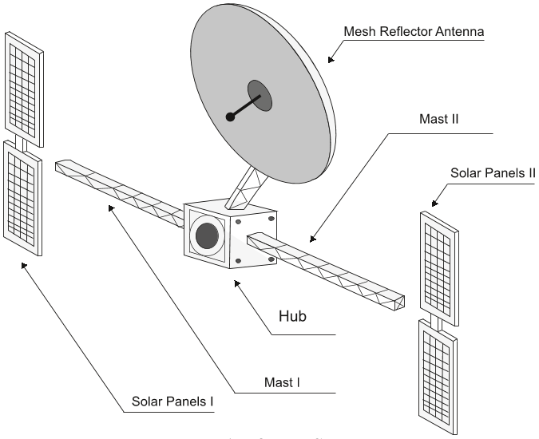 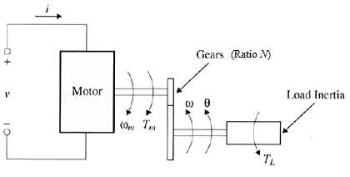

data for the gear motor

N = 300 ratio of reduction

Jm = 0.001 m2kg DC motor inertia

ke = k = 0.2 en V/rad/s ou en Nm/A torque constant

Re = 2 

Le = 2 mH

data for the load

Jl = 100 m2kg load inertia

Kl= 1e4 N/m load stiffness N/m

b = 10 Viscous coefficient

***Questions***

1. Write the electrical equation of the motor and the mechanical equation of the gear motor connected to the load.
2. *Case $T_{L}=0$.*

2.1 - Compute the transfer function $\frac{θ}{v}$

2.2 - With Matlab, compute the poles of the transfer function:

* method 1: define the numerator and denominator and use the function *roots*
* method 2: define a system (function *tf*) and use the function *zpkdata*

With Matlab, plot the Bode diagrams (function *bode*), the Nichols diagram (function *nichols*), and the root locus (function *rlocus).* Try also the LTIview Graphical Interface (function *ltiview*)

2.3 – With Simulink, make the bock diagram of the system (use inport and outport blocks to define input and output) and, with Matlab, compute the state-space representation with $θ$ as output using the function *linmod.* Then plot the Bodediagrams (you must of course find the same Bode diagrams as in question 2.1 (hint: to plot two curves on the same diagram, use the function *hold on*).

Compute the eigenvalues of the matrix A (function *eig*), the natural frequencies and damping ratios of the system.

Compare the eigenvalues with the poles of the transfer function.

2.4 – Observe the step response (function *step* or ltiview)

1. *Case $T_{L}=b\dot{θ}+K_{l}θ$*

3.1 - Compute the transfer function $\frac{θ}{v}$

3.2 - With Matlab, compute the poles of the transfer function and plot the Bode diagrams, the Nichols diagram, and the root locus*.*

Analyze the effect of the load.

3.3 – With Simulink, make the bock diagram of the system. With Matlab, compute the state-space representation with $θ$ as output using the function *linmod*, the eigenvalues of the matrix A, the natural frequencies and damping ratios of the system. Plot the Bodediagrams.

* 1. – Observe the step response and the effect of the load.
  2. – Use the equations to write a state-space representation with $θ$ as output. Compare with the state-space representation obtained in 3.2. Is the state-space representation unique?
  3. - Study the observability (functions *obssv* and *rank*) and the controllability of the system (functions *ctrb* and *rank*)